Demo Process

1. Normal Process
2. The complete lifecycle of an app. (short.yml)(submit twice)

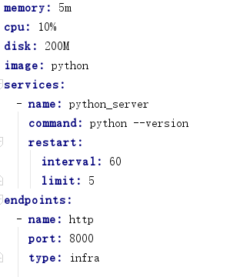

set TREADMILL_ZOOKEEPER=zookeeper://foo@192.168.1.121:2181

set TREADMILL_CELL=local

set TREADMILL_LDAP_SEARCH_BASE=ou=treadmill,dc=tw,dc=treadmill

python.exe -m treadmill admin master app schedule --env prod --proid treadmld --manifest treadmill/deploy/short.yml short.foo –n 2

python.exe -m treadmill admin trace short.foo#0000000096

1. Normal scheduling and normal operation. (long.yml)

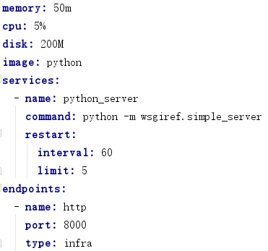

python.exe -m treadmill admin master app schedule --env prod --proid treadmld --manifest treadmill/deploy/long.yml long.foo –n 2

python.exe -m treadmill admin trace long.foo#0000000096

1. User logs on desktop. (The dynamic join and exit of the desktop)

desktop2 logs on

python.exe -m treadmill admin master app schedule --env prod --proid treadmld --manifest treadmill/deploy/long.yml long.foo –n 2

1. Blackout a desktop.

python.exe -m treadmill admin blackout server --server desktop1 --reason test

python.exe -m treadmill admin blackout server --clear --server desktop1 --reason test

1. Exceptions
2. Application inside docker container crashes.(abort.yml)

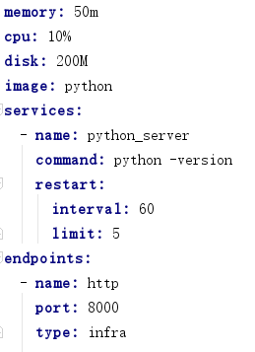

python.exe -m treadmill admin master app schedule --env prod --proid treadmld --manifest treadmill/deploy/abort.yml abort.foo –n 2

python.exe -m treadmill admin trace abort.foo#0000000096

1. The docker image cannot be excuted/started. (error.yml)

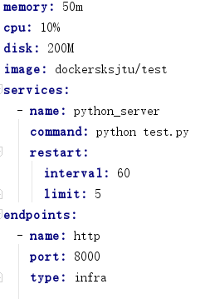

python.exe -m treadmill admin master app schedule --env prod --proid treadmld --manifest treadmill/deploy/error.yml error.foo –n 2

python.exe -m treadmill admin trace error.foo#0000000096

1. Some services of windows agent are stopped.

some services of desktop2 are stopped.

1. Treadmill zookeeper service is down.

./zkServer.sh stop

./zkServer.sh start

1. Network crashes.
2. WorkDesktop is shut down.